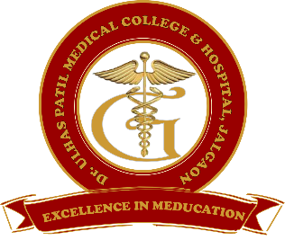**Godavari Foundation’s**

**DR. ULHAS PATIL MEDICAL COLLEGE & HOSPITAL,**

**Recognized by Medical Council of India, Approved by Central Govt. of India, New Delhi,**

**Letter no. MCI-34(41)/2012-med./158127, dated 05/02/2013**

**Affiliated to Maharashtra University of Health Sciences, Nashik [College Code-1306]**

**Jalgaon-Bhusawal Road, NH-6, Jalgaon Kh, Tal. & Dist. Jalgaon 425309**

**Tel. No. (0257)2366657, 2366678 Fax No. 0257-2366648**

**Email ID :** [**dupmcj@yahoo.in**](mailto:dupmcj@yahoo.in) **Web Site :** [**www.dupmc.ac.in**](http://www.dupmc.ac.in)

**BEST PRACTICES**

**Title of the practice: Self-directed learning in the library**

**Objectives of the Practice:**

Students need various skills and attitudes towards learning for successful independent study. This step involves students conducting a self-evaluation of their current situation, and study habits with independent learning in the library.

**The practice:**

To maintain independent study a strong disciplinary action among students, the institute has made some changes in its policies. Accordingly, students must go to the library for study purposes between 9-12 pm. Attendance will be taken by one of the institution’s representatives and if someone is found absent strong action would to taken. The message will be sent to their parents.

In addition to this, if anyone is absent, without prior information, or is absent in lectures, practicals or clinical postings strict actions will be taken for such misconduct and a direct message would be sent to their parents.

As part of this, a collective attendance report will be made every month. A regular warning will be given to the students who are unable to maintain their presence in lecture, practical or clinical posting. If the attendance of any student is found to be less than 75%, such student will be not allowed to appear in the university exams.

**Evidence of Success:**

It increases students’ self-confidence, independence, motivation, and also the development of different skills for lifelong learning. It seems that the success rate of students increases each year after the implementation of this program. Moreover, many different educational institutes use it to promote independent learning.

**Problems Encountered and Resources Required:**

Not knowing what to learn. If you are new to a subject, it is often very challenging to decide what to begin learning, Self-motivation and interest, too much choice, and the easy way out. Despite its drawbacks, self-directed learning should not be written off. Instead, we need to think of better ways to apply the concept.